Sam Kramer

ENERGY 294 Midterm

5/12/18

**Problem 1.1)**

The capacity of the battery at 1C discharge was found to be 1.962 Ah. Based on this capacity, a 1C discharge current is 1.962 A and a 4C discharge current is 7.849 A. The sign convention for current in this problem is positive for discharge.

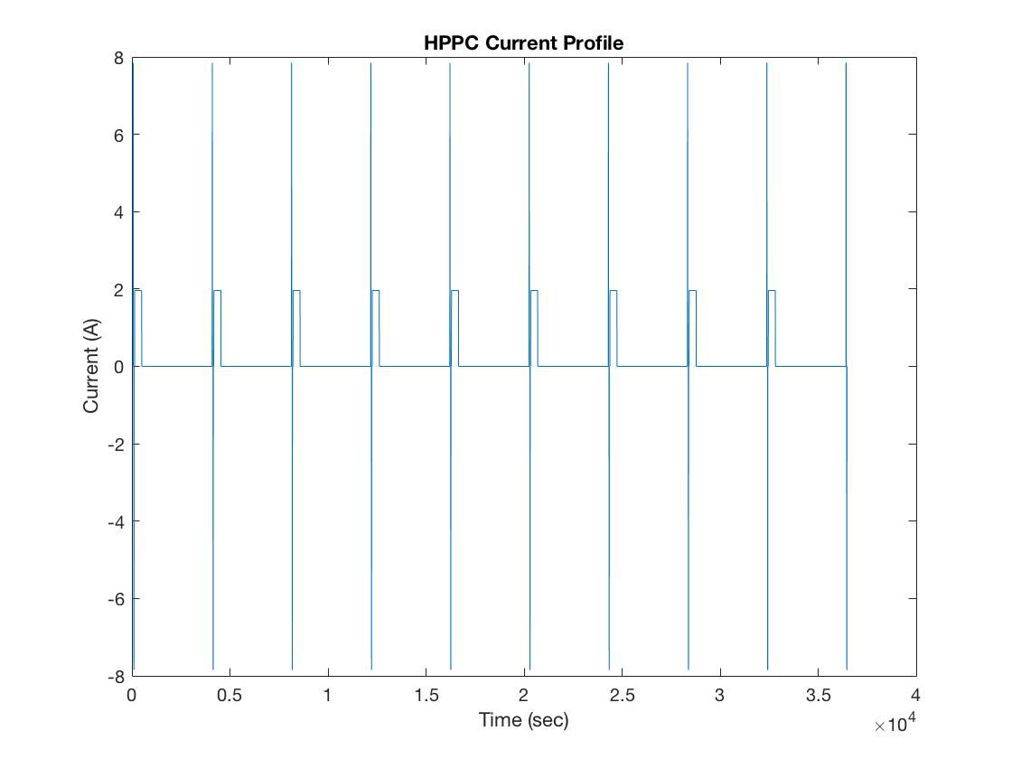

**Problem 1.2)**

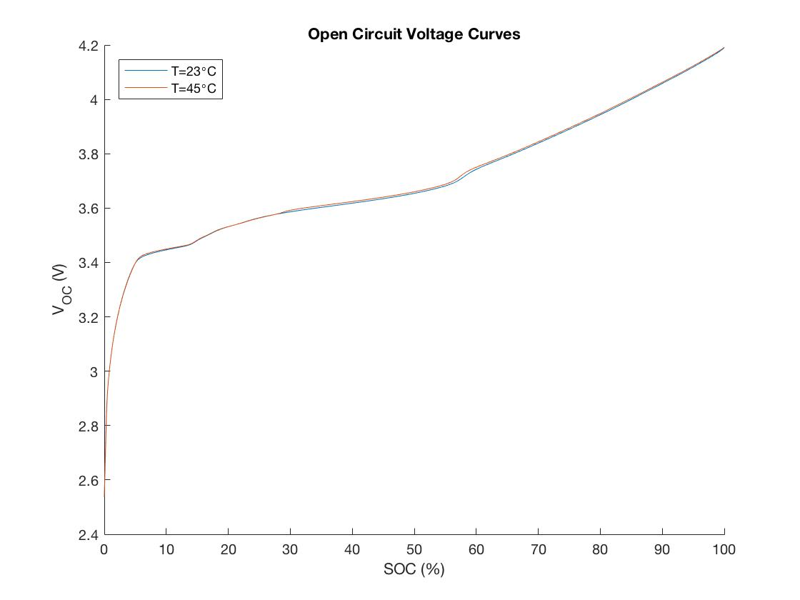

**Problem 2a) Initial Parameter Guesses using Graphical Method**

|  |  |  |  |
| --- | --- | --- | --- |
| **T = 23˚C** | | | |
| **SOC** | **R0** | **R1** | **C1** |
| 90% | 0.03038 | 0.00654 | 1841.0 |
| 80% | 0.03084 | 0.00761 | 1582.7 |
| 70% | 0.03059 | 0.00740 | 1626.3 |
| 60% | 0.03013 | 0.00638 | 1884.9 |
| 50% | 0.02824 | 0.00485 | 2274.8 |
| 40% | 0.02895 | 0.00490 | 2456.5 |
| 30% | 0.02962 | 0.00495 | 2225.9 |
| 20% | 0.03181 | 0.00557 | 1800.6 |

|  |  |  |  |
| --- | --- | --- | --- |
| **T = 45˚C** | | | |
| **SOC** | **R0** | **R1** | **C1** |
| 90% | 0.02318 | 0.00526 | 1909.8 |
| 80% | 0.02344 | 0.00623 | 1610.4 |
| 70% | 0.02364 | 0.00649 | 1856.9 |
| 60% | 0.02364 | 0.00608 | 1983.4 |
| 50% | 0.02221 | 0.00403 | 2486.4 |
| 40% | 0.02221 | 0.00393 | 2554.8 |
| 30% | 0.02262 | 0.00398 | 2521.8 |
| 20% | 0.02349 | 0.00419 | 2399.9 |

**Problem 2b) Parameter Results from fminsearch**

|  |  |  |  |
| --- | --- | --- | --- |
| **fminsearch Results: T=23˚C** | | | |
| **SOC** | **R0** | **R1** | **C1** |
| 90% | 2.96E-02 | 1.17E-02 | 1.01E+03 |
| 80% | 2.98E-02 | 1.52E-02 | 8.78E+02 |
| 70% | 2.95E-02 | 1.77E-02 | 8.72E+02 |
| 60% | 2.85E-02 | 1.64E-02 | 8.68E+02 |
| 50% | 2.73E-02 | 9.35E-03 | 1.20E+03 |
| 40% | 2.82E-02 | 1.10E-02 | 1.22E+03 |
| 30% | 2.85E-02 | 1.08E-02 | 1.15E+03 |
| 20% | 3.03E-02 | 9.63E-03 | 1.01E+03 |

|  |  |  |  |
| --- | --- | --- | --- |
| **fminsearch Results: T=45˚C** | | | |
| **SOC** | **R0** | **R1** | **C1** |
| 90% | 2.26E-02 | 8.19E-03 | 1.24E+03 |
| 80% | 2.26E-02 | 9.82E-03 | 1.07E+03 |
| 70% | 2.24E-02 | 1.10E-02 | 1.00E+03 |
| 60% | 2.21E-02 | 1.15E-02 | 9.93E+02 |
| 50% | 2.14E-02 | 6.58E-03 | 1.43E+03 |
| 40% | 2.15E-02 | 7.67E-03 | 1.49E+03 |
| 30% | 2.17E-02 | 6.54E-03 | 1.44E+03 |
| 20% | 2.21E-02 | 5.54E-03 | 1.30E+03 |

**Problem 2c) Parameter Results from Genetic Algorithm**

|  |  |  |  |
| --- | --- | --- | --- |
| **Genetic Algorithm Results: T=23˚C** | | | |
| **SOC** | **R0** | **R1** | **C1** |
| 90% | 2.94E-02 | 1.20E-02 | 9.42E+02 |
| 80% | 3.11E-02 | 1.06E-02 | 1.14E+03 |
| 70% | 2.95E-02 | 1.75E-02 | 8.78E+02 |
| 60% | 2.98E-02 | 1.52E-02 | 9.81E+02 |
| 50% | 2.76E-02 | 9.04E-03 | 1.33E+03 |
| 40% | 2.92E-02 | 8.71E-03 | 1.50E+03 |
| 30% | 2.81E-02 | 1.11E-02 | 1.03E+03 |
| 20% | 2.78E-02 | 9.92E-03 | 5.90E+02 |

|  |  |  |  |
| --- | --- | --- | --- |
| **Genetic Algorithm Results: T=45˚C** | | | |
| **SOC** | **R0** | **R1** | **C1** |
| 90% | 2.32E-02 | 7.21E-03 | 1.43E+03 |
| 80% | 2.28E-02 | 1.02E-02 | 1.13E+03 |
| 70% | 2.23E-02 | 1.16E-02 | 9.67E+02 |
| 60% | 2.05E-02 | 1.27E-02 | 7.87E+02 |
| 50% | 2.15E-02 | 6.35E-03 | 1.33E+03 |
| 40% | 2.14E-02 | 7.79E-03 | 1.40E+03 |
| 30% | 2.20E-02 | 8.97E-03 | 1.58E+03 |
| 20% | 2.06E-02 | 7.10E-03 | 7.75E+02 |

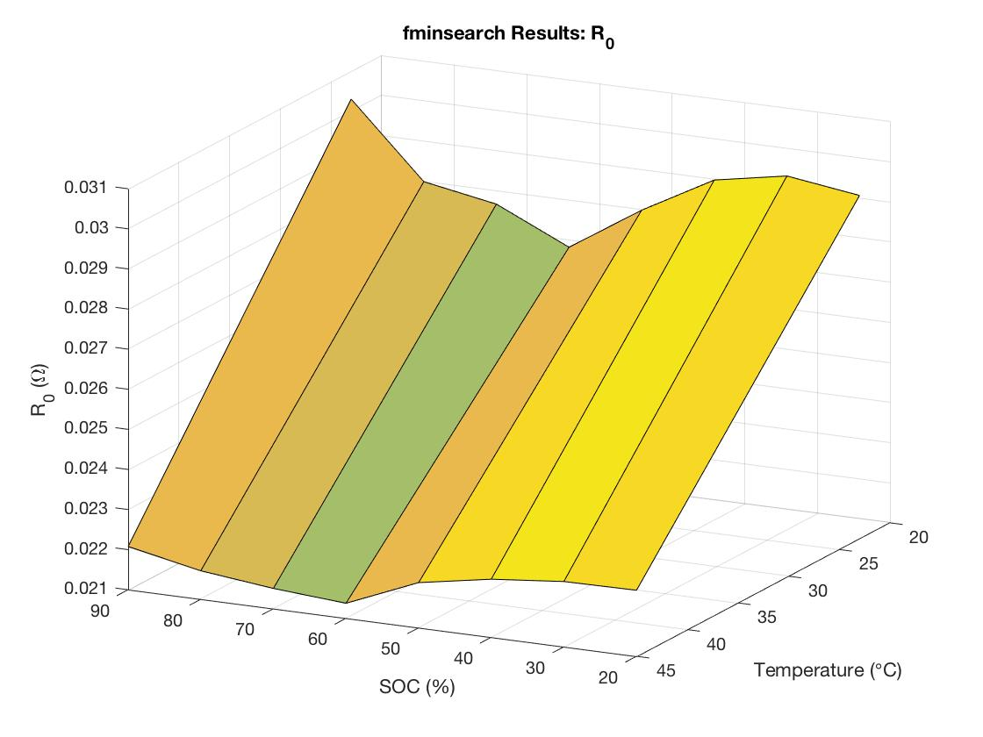**2d) fminsearch Surface Plot**

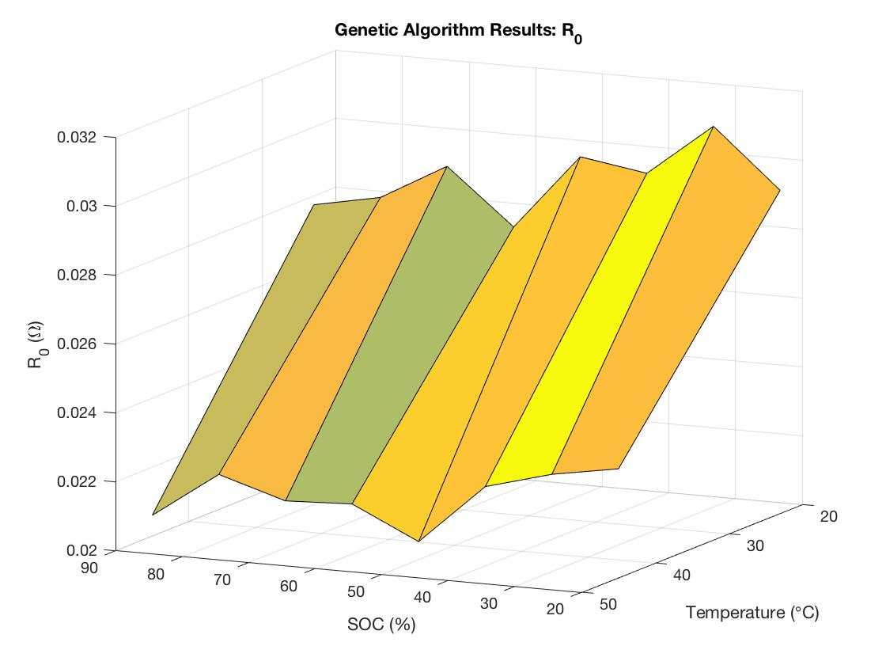**2e) Genetic Algorithm Surface Plot**

**Problem 2f) Comparison of Methods**

The main advantage of the fminsearch method compared to the genetic algorithm is that it less computationally intensive and therefore is significantly faster to run. Because fminsearch is given a location to start the optimization at, the algorithm may get stuck at a local minimum near this start point. This may be an advantage if one is confident that the answer is in the vicinity of the start point, but it could be a disadvantage if the goal is to minimize the error as much as possible. The genetic algorithm, on the other hand, generates candidates within the entire space within the specified constraints. This makes it less likely to get stuck in a local minimum, but it requires more computational resources.

**Problem 2g)**

|  |  |  |
| --- | --- | --- |
| **Overall RMS Error** | | |
|  | **fminsearch** | **ga** |
| **T=23˚C** | 0.327% | 0.335% |
| **T=45˚C** | 0.203% | 0.198% |

The genetic algorithm performed better than the fminsearch for both 23˚C and 45˚C, although they were quite close. There was a much more significant difference between the 23˚C case and the 45˚C case than there was between the two search methods.

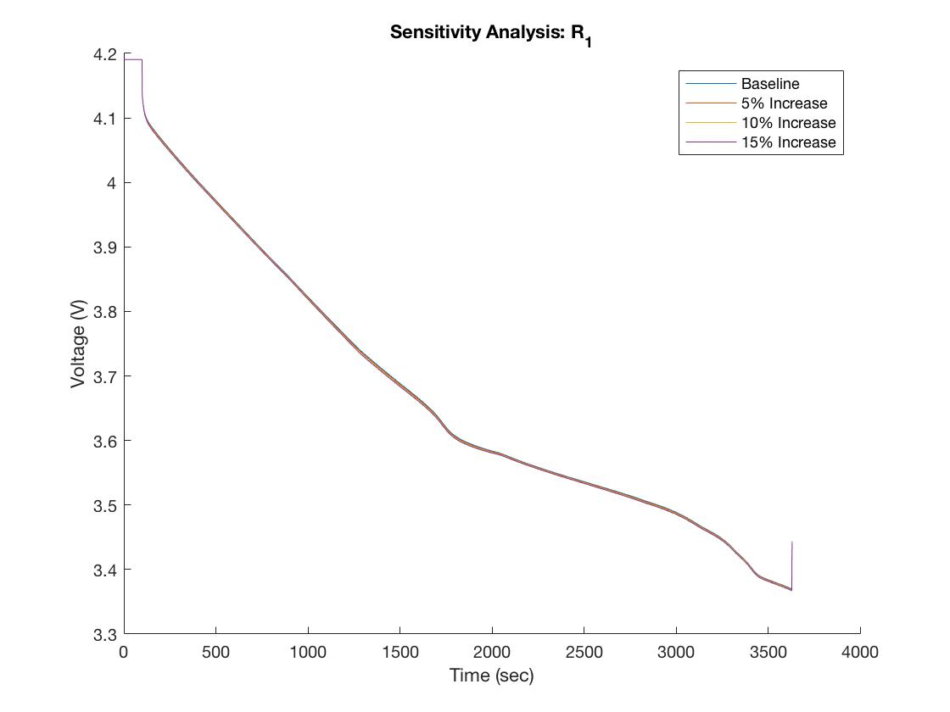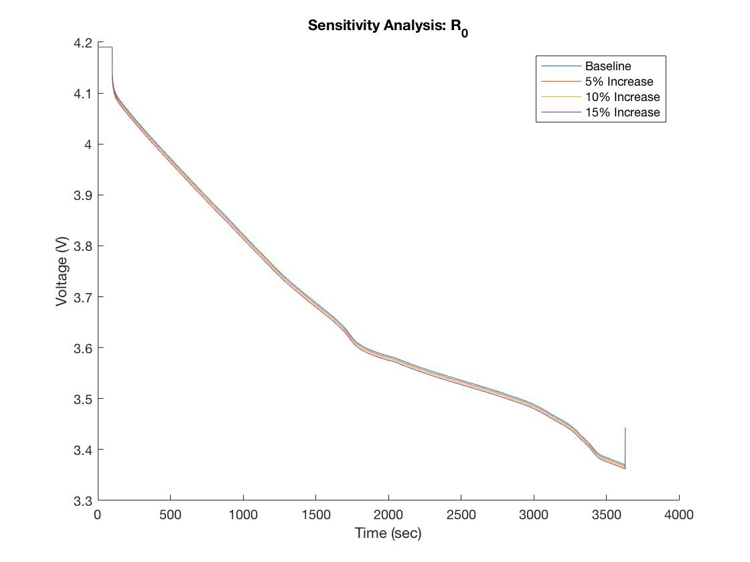**2h) Sensitivity Analysis (conducted on Genetic Algorithm results for T=23˚C)**

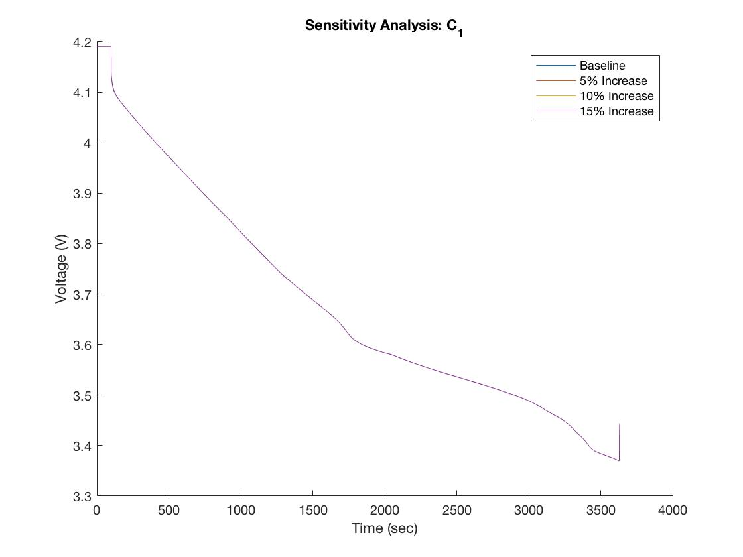**2i) Sensitivity Analysis Comments**

Because this sensitivity analysis uses a constant current input, the expression for the voltage drop across the R1C1 branch of the circuit can be solved easily, yielding the expression:

$$V_{1}=R_{1}I+ke^{-\frac{1}{R_{1}C_{1}}t}$$

where k is an integration constant. Therefore, the value of C1 only affects transient behavior in the system because of the exponential decay function. Since R1*C1 10 sec, changing C1 will have very little impact on the system after a short amount of time. As t gets large, the voltage of the battery becomes:

$$V_{batt}= V_{OC}-I(R_{0}+R_{1})$$

Since R0 is 2-3 times larger than R1, the system is much more sensitive to a percentage change in R0 than it is to the same percentage change in R1.

**Model Validation**

The overall RMS error obtained for the US06 model validation was 0.165%. The range of SOC achieved throughout the trial is incredibly narrow. This suggests that the BMS of the vehicle is working to constrain the SOC, and this car is likely a HEV. It is certainly not a BEV, because the SOC would have to vary much more than is observed in order to cover any meaningful distance. It is possible that the car was a PHEV, since these vehicles do allow for SOC depletion until a certain point, at which point SOC is constrained, but the car started at a modest SOC.

